Participant
Linkt Health Username: [site email+ID]
Linkt Health Temp Password: [insert temp pass]
Linkt Health Password: [insert permanent pass]

Study Partner
Linkt Health Username: [site email+ID]
Linkt Health Temp Password: [insert temp pass]
Linkt Health Password: [insert permanent pass]

ALLFTD Phone Application
ALLFTD Participant Take-Home Instructions and Information

Thank you for agreeing to use the ALLFTD phone app. This App is designed to investigate the potential benefit that modern technologies may have for advancing our knowledge of frontotemporal lobar degeneration (FTLD). We are using a cell phone app to learn more about you! Specifically, we are planning to do this by having you answer surveys, play memory and thinking games, and speaking tasks. Additionally, you may be asked to complete some motor tasks like walking for a short period of time or tapping your fingers on your cell phone screen.

We think that having you complete these tasks using the App will help us better monitor changes in your daily functioning and limit your burden by not having to travel to the clinic more frequently. We anticipate that you will complete all of the App tasks in a location of your choosing, aka not the clinic! We ask that where you choose to complete these tasks is free from noise or distractions.

What will I need to do to complete App participation?
To complete your App participation, you will need to complete your prompted tasks (like memory and thinking games, surveys, motor assessments, etc.) on Linkt (the name of the cell phone App) three times over an approximately two-week period. We believe that having you take the tests multiple times will help us ensure the highest quality data. You will have some flexibility in when you take the tests (i.e., a 3-day testing window for each chapter). Once you complete these tasks you will receive your Amazon gift card code via an in-App message. Banner notifications will prompt you to complete these tasks again! We anticipate that you’ll complete tasks through the App every 6 months.
Participation Safety:
Two of the app tasks may use sensors within the phone to measure walking and standing. If either of these actions are uncomfortable or unsafe, you will have the opportunity to skip these tasks while still receiving full credit towards your overall participation. We hope these tasks will be attempted whenever possible, but safety is our top priority.
App-Visit Timeline:

Below is a timeline for your first App-visit (reminder that the icon on your phone will be labeled: Linkt). You will be asked to complete three separate chapters with the App to complete each App-visit. Each chapter will consist of a few different tasks, and we anticipate each task will take 2-5 minutes. It is likely that each chapter (depicted below in number bubbles) will take about 30 minutes to complete. You can take up to 3 days to complete all of the tasks associated with that chapter. You will have one break day in-between each set of tasks where no tasks are available for completion. There will be a message available on this break day with details about the arrival of your next set of tasks.

1: __Date (##/##/####)____ 2: __Date (##/##/####)____ 3. __Date (##/##/####)____ 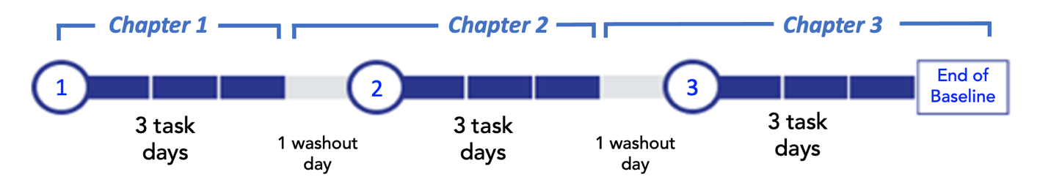

During each chapter, you will be prompted to complete several memory and thinking games. Not every chapter is identical, but you may be asked to complete:
- Passage Reading
- Color Clash
- Humi’s Bistro
- Animal Parade
- Ducks in a Row
- Go Sushi Go!
- Speech Tasks
- Card shuffle
- Finger tapping
- Walking task
- Balancing task
You will receive a notification on your phone with the following reminders:
- Arrival of new tasks to complete
- Beginning of a new chapter
- Arrival of an in-app message (e.g. the Amazon gift code)
- 24 hours prior to expiration of remaining tasks
- 24 hours since previous passive data upload

Your study partner will receive an in-app message reminding them to check in with the you and encourage you to complete any unfinished tasks.

Each set of tasks you complete will earn you $20 in Amazon credit. You will receive in-App notifications with Amazon Gift Card Codes. If you do not complete all activities in a chapter within the three-day time period, you will not receive payment for that chapter.

Subsequent App-Visits:

A coordinator will reach out to you approximately one-to-two weeks prior to your next App-visit timing window (every 6 months). You will be asked to complete three separate sets of tasks in that App-visit as well. You will also receive an announcement from the app that these tasks will become available. We hope that you will continue to participate in the ALLFTD App for the duration of the ALLFTD study! We believe that this technology is very promising, and your participation will help us answer important questions!

